Bài 2:

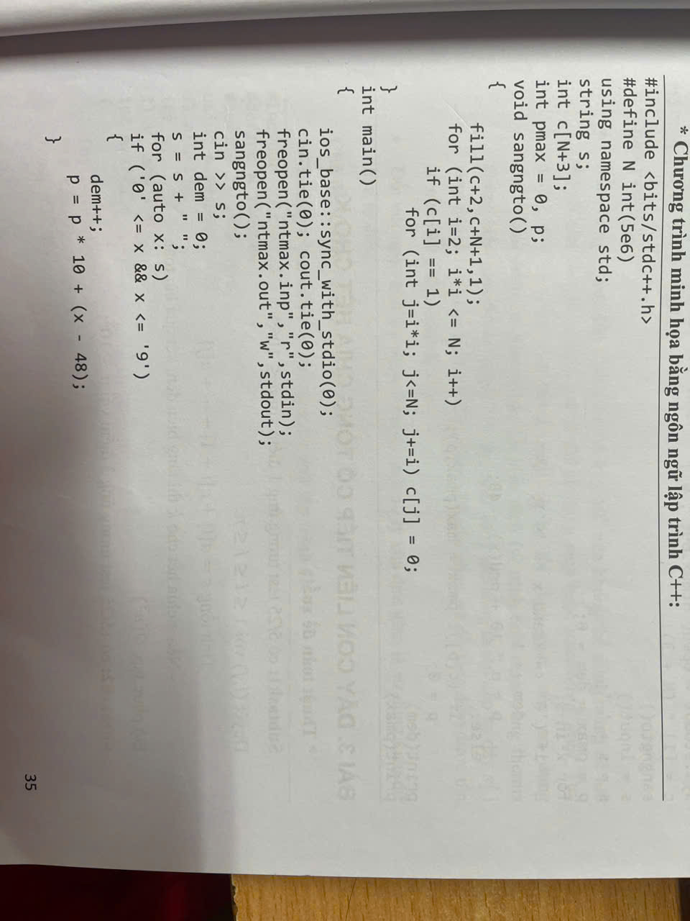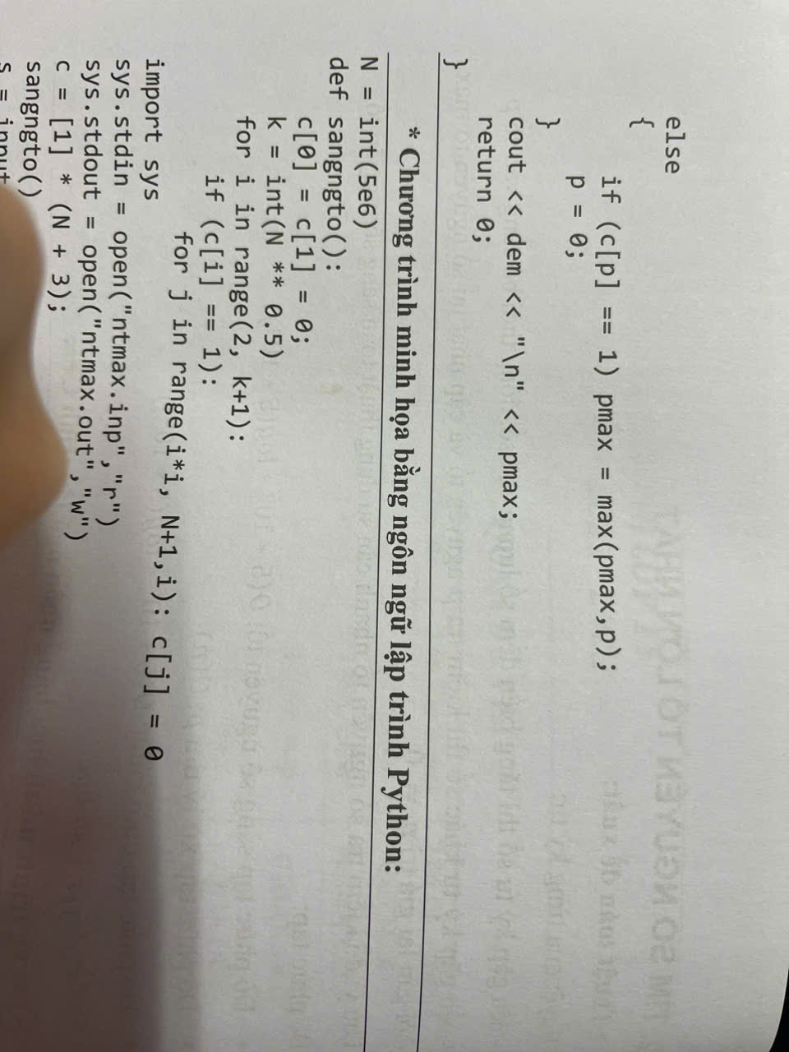

Bài 3:

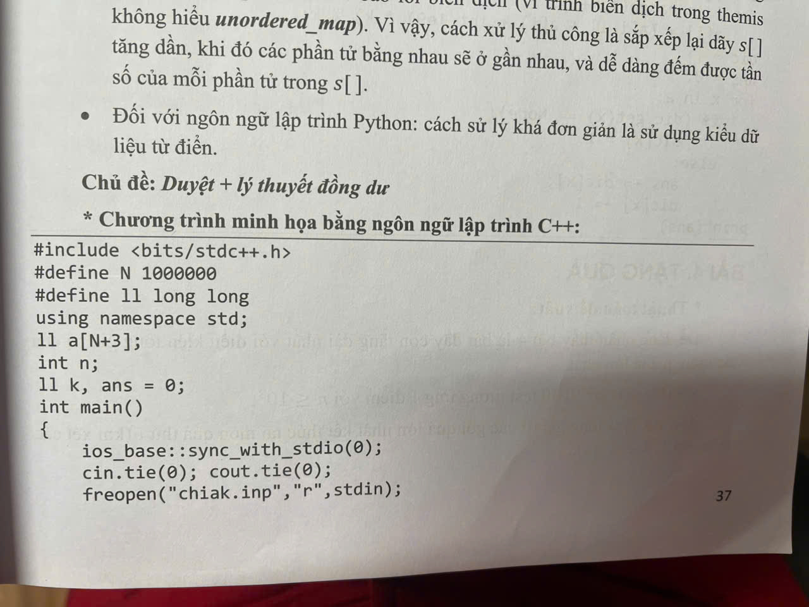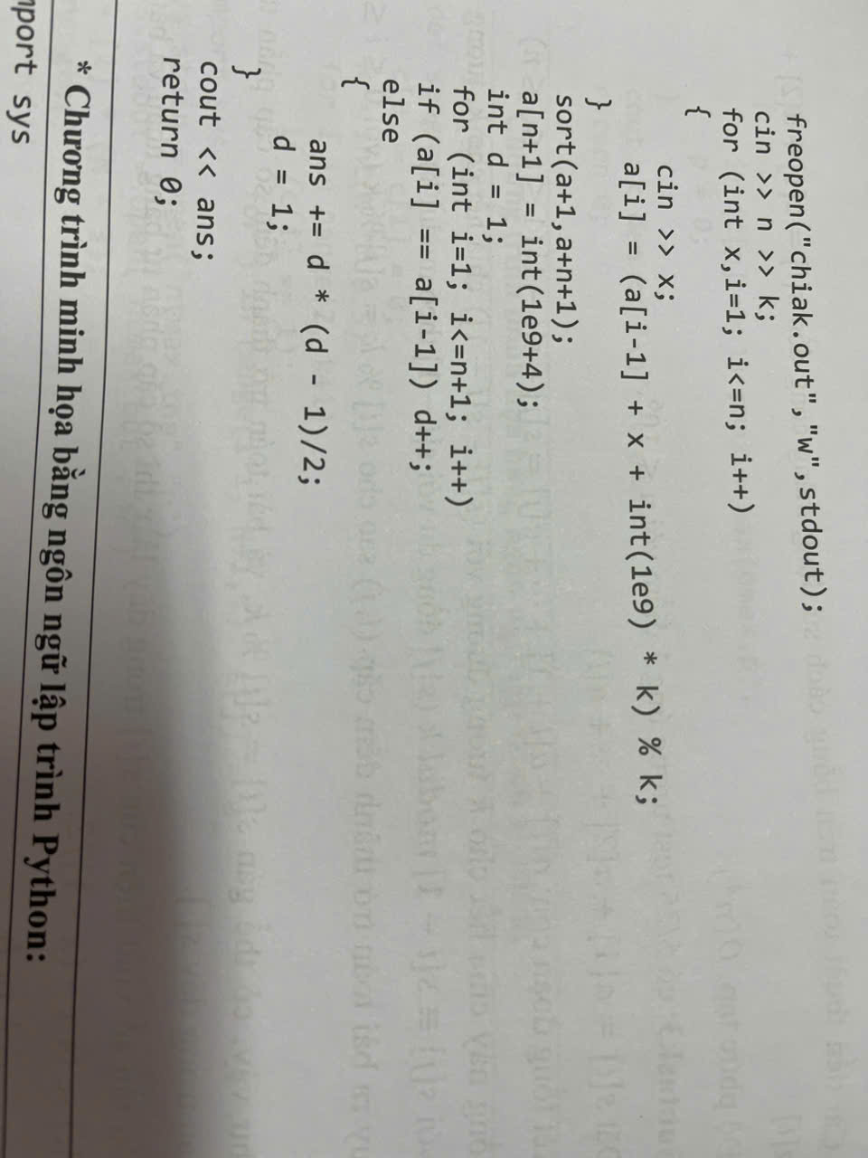

Bài 4:

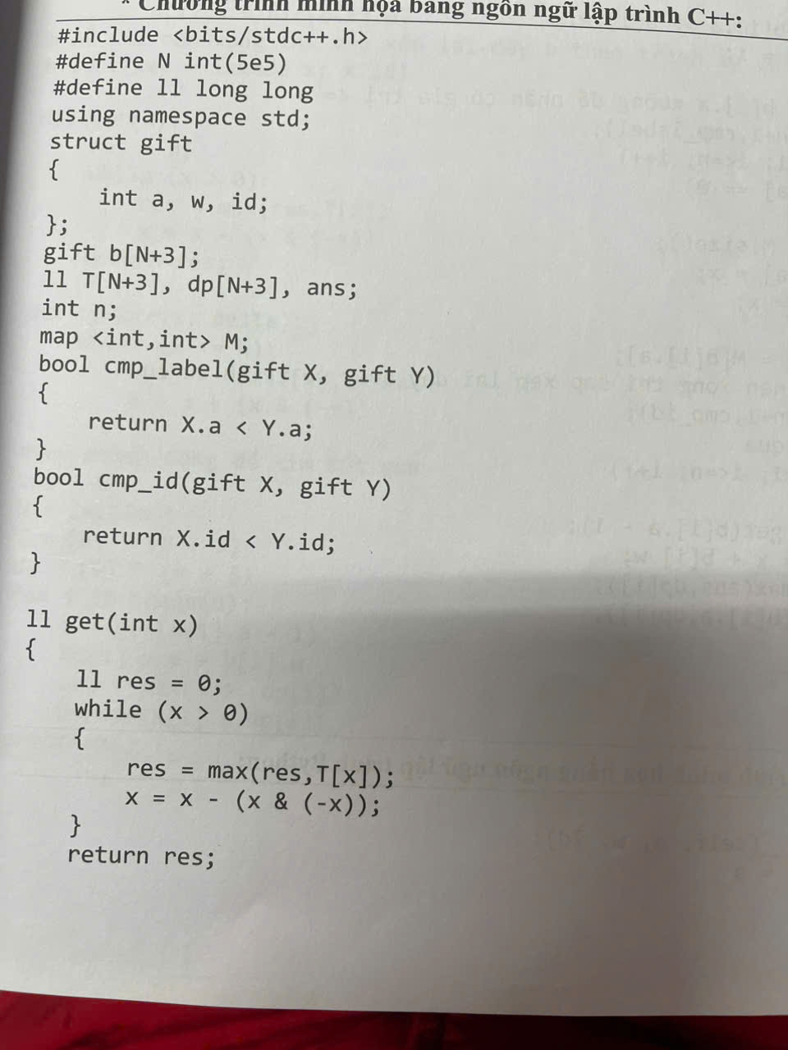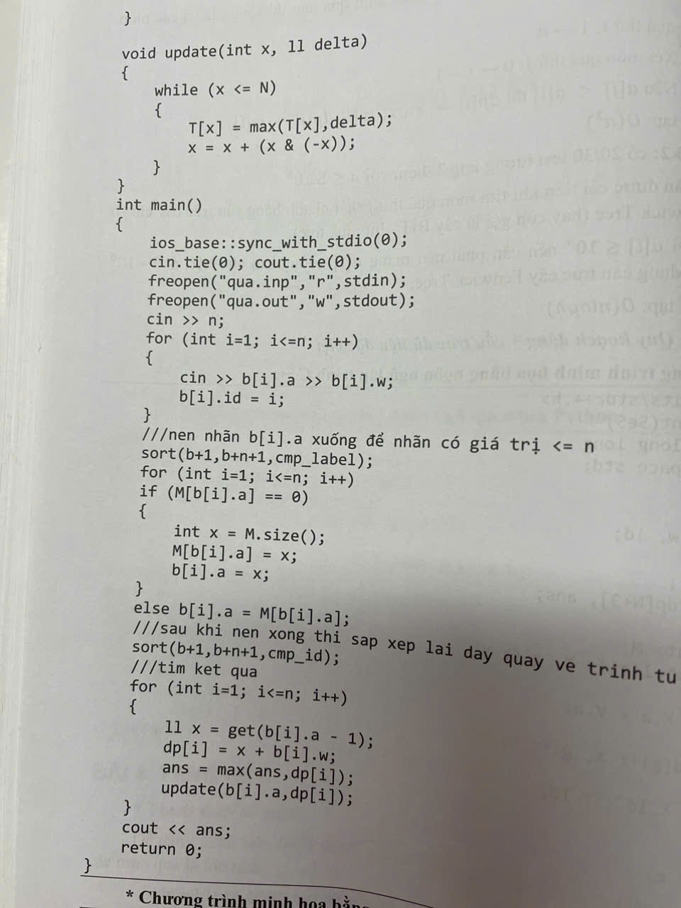

Bài 5:

#include <bits/stdc++.h>

using namespace std;

int n,k,a[100001];

int maxSum(int arr[], int n, int k)

{

if (n < k)

{

return -1;

}

int res = 0;

for (int i = 0; i < k; i++) res += arr[i];

int curr_sum = res;

for (int i = k; i < n; i++)

{

curr_sum += arr[i] - arr[i - k];

res = max(res, curr_sum);

}

return res;

}

int solve(int arr[], int n, int k)

{

int max_len = 0, l = 0, r = n, m;

while (l <= r)

{

m = (l + r) / 2;

if (maxSum(arr, n, m) > k) r = m - 1;

else

{

l = m + 1;

max_len = m;

}

}

if(max_len==0) return -1;

else return max_len;

}

int main()

{

cin>>n>>k;

for(int i=0;i<n;i++) cin>>a[i];

cout << solve(a, n, k);

return 0;

}

**Bài 6.** (2.0 điểm)

Chương trình tham khảo: Tệp BAI5.CPP

#include <bits/stdc++.h>

using namespace std;

using lli = long long;

const int maxN = 5000;

const int maxSum = 2e6;

int n, L, R; int a[maxN]; lli c[maxN];

int data[2 * maxSum + 1];

int* cnt = data + maxSum;

void ReadInput()

{

cin >> n;

for (int i = 0; i < n; ++i) cin >> a[i];

}

void Init()

{

fill(cnt - maxSum, cnt + maxSum + 1, 0);

fill(c, c + n, 0LL);

}

void Solve()

{

for (int k = 2; k + 1 < n; ++k)

{

for (int i = k - 2; i >= 0; --i) ++cnt[a[k - 1] + a[i]];

for (int x = k + 1; x < n; ++x) c[x] += cnt[a[x] - a[k]];

}

}

void Print()

{

for (int x = 0; x < n; ++x)

cout << c[x] << ' ';

}

int main()

{

ios_base::sync_with_stdio(false); cin.tie(nullptr);

ReadInput(); Init(); Solve(); Print();

}